**Acropolis Institute Of Technology And Research,**

**Indore(M.P.)**



**Subject – Operating Sytem(OS)**

**(CY-405)**

**Name – Yashira Shaikh**

**Enrollment No. - 0827CY221071**

**Branch - CS(Cyber Security)**

**Semester- 4th sem**

**Submitted To –Mrs. Vandana Kate**

Introduction to UNIX System

Unix is an Operating System that is truly the base of all Operating Systems like Ubuntu, Solaris, POSIX, etc. It was developed in the 1970s by Ken Thompson, Dennis Ritchie, and others in the AT&T Laboratories. It was originally meant for programmers developing software rather than non-programmers.

Unix and the C were found by AT&T and distributed to government and academic institutions, which led to both being ported to a wider variety of machine families than any other operating system. The main focus that was brought by the developers in this operating system was the Kernel. Unix was considered to be the heart of the operating System. The system Structure of Unix OS are as follows:

UNIX is a family of multitasking, multiuser computer operating systems developed in the mid 1960s at Bell Labs. It was originally developed for mini computers and has since been ported to various hardware platforms. UNIX has a reputation for stability, security, and scalability, making it a popular choice for enterprise-level computing.

The basic design philosophy of UNIX is to provide simple, powerful tools that can be combined to perform complex tasks. It features a command-line interface that allows users to interact with the system through a series of commands, rather than through a graphical user interface (GUI).

Some of the key features of UNIX include:

Multiuser support: UNIX allows multiple users to simultaneously access the same system and share resources.

Multitasking: UNIX is capable of running multiple processes at the same time.

Shell scripting: UNIX provides a powerful scripting language that allows users to automate tasks.

Security: UNIX has a robust security model that includes file permissions, user accounts, and network security features.

Portability: UNIX can run on a wide variety of hardware platforms, from small embedded systems to large mainframe computers.

Communication: UNIX supports communication methods using the write command, mail command, etc.

Process Tracking: UNIX maintains a record of the jobs that the user creates. This function improves system performance by monitoring CPU usage. It also allows you to keep track of how much disk space each user uses, and the use that information to regulate disk space.

Today, UNIX is widely used in enterprise-level computing, scientific research, and web servers. Many modern operating systems, including Linux and macOS, are based on UNIX or its variants.

An image that demonstrates the structure of the Unix operating system is –

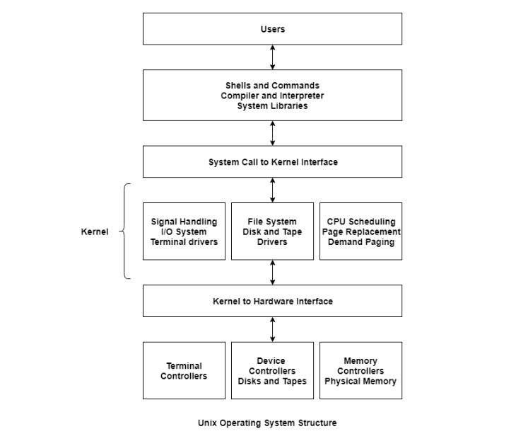

While working with UNIX OS, several layers of this system provide interaction between the pc hardware and the user. Following is the description of each and every layer structure in UNIX system:

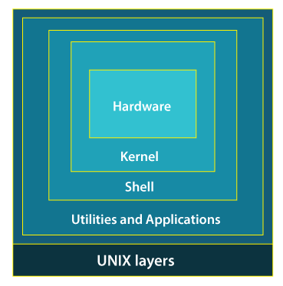

Layer-1: Hardware -

This layer of UNIX consists of all hardware-related information in the UNIX environment.

Layer-2: Kernel -

The core of the operating system that's liable for maintaining the full functionality is named the kernel. The kernel of UNIX runs on the particular machine hardware and interacts with the hardware effectively.

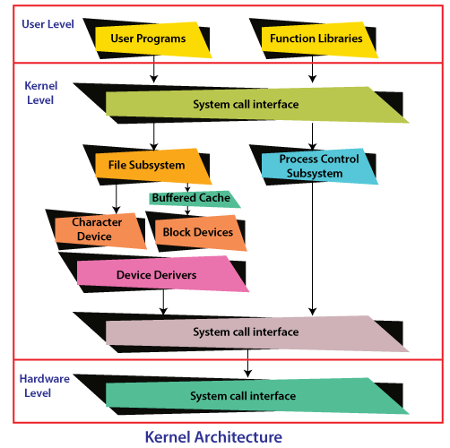

It also works as a device manager and performs valuable functions for the processes which require access to the peripheral devices connected to the computer. The kernel controls these devices through device drivers.

The kernel also manages the memory. Processes are executed programs that have owner's humans or systems who initiate their execution.

The system must provide all processes with access to an adequate amount of memory, and a few processes require a lot of it. To make effective use of main memory and to allocate a sufficient amount of memory to every process. It uses essential techniques like paging, swapping, and virtual storage.

Layer-3: The Shell -

The Shell is an interpreter that interprets the command submitted by the user at the terminal, and calls the program you simply want.

It also keeps a history of the list of the commands you have typed in. If you need to repeat a command you typed it, use the cursor keys to scroll up and down the list or type history for a list of previous commands. There are various commands like cat, mv, cat, grep, id, wc, and many more.

Types of Shell in UNIX System:

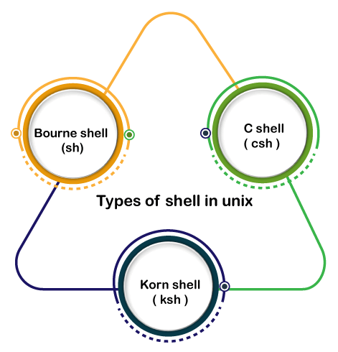

Bourne Shell: This Shell is simply called the Shell. It was the first Shell for UNIX OS. It is still the most widely available Shell on a UNIX system.

C Shell: The C shell is another popular shell commonly available on a UNIX system. The C shell was developed by the University of California at Berkeley and removed some of the shortcomings of the Bourne shell.

Korn Shell: This Shell was created by David Korn to address the Bourne Shell's user-interaction issues and to deal with the shortcomings of the C shell's scripting quirks.

Layer-4: Application Programs Layer –

It is the outermost layer that executes the given external applications. UNIX distributions typically come with several useful applications programs as standard. For Example: emacs editor, StarOffice, xv image viewer, g++ compiler etc.

Unix file operations

Navigating filesystem and managing files and access permissions:

[ls](https://www.unixtutorial.org/commands/ls) – list files and directories

cp – copy files (work in progress)

[rm](https://www.unixtutorial.org/commands/rm) – remove files and directories (work in progress)

mv – rename or move files and directories to another location

chmod – change file/directory access permissions

[chown](https://www.unixtutorial.org/commands/chown) – change file/directory ownership

Unix directory management commands

Navigating filesystems and managing directories:

[cd](https://www.unixtutorial.org/commands/cd) – change directory

[pwd](https://www.unixtutorial.org/commands/pwd) – confirm current directory

[ln](https://www.unixtutorial.org/commands/ln) – make links and symlinks to files and directories

[mkdir](https://www.unixtutorial.org/commands/mkdir) – make new directory

rmdir – remove directories in Unix

Networking commands in Unix

Most useful commands for inspecting network setup and exploring network connections and ports:

[ifconfig](https://www.unixtutorial.org/commands/ifconfig) – show and set IP addresses (found almost everywhere)

[ip](https://www.unixtutorial.org/commands/ip) – show and set IP addresses (in recent Linux versions)

ping – check if remote host is reachable via ICMP ping

netstat – show network stats and routing information

Advantages of UNIX:

Stability: UNIX is known for its stability and reliability. It can run for long periods of time without requiring a reboot, which makes it ideal for critical systems that need to run continuously.

Security: UNIX has a robust security model that includes file permissions, user accounts, and network security features. This makes it a popular choice for systems that require high levels of security.

Scalability: UNIX can be scaled up to handle large workloads and can be used on a variety of hardware platforms.

Flexibility: UNIX is highly customizable and can be configured to suit a wide range of needs. It can be used for everything from simple desktop systems to complex server environments.

Command-line interface: UNIX’s command-line interface allows for powerful and efficient interaction with the system.

Disadvantages of UNIX:

Complexity: UNIX can be complex and difficult to learn for users who are used to graphical user interfaces (GUIs).

Cost: Some UNIX systems can be expensive, especially when compared to open-source alternatives like Linux.

Lack of standardization: There are many different versions of UNIX, which can make it difficult to ensure compatibility between different systems.

Limited software availability: Some specialized software may not be available for UNIX systems.

Steep learning curve: UNIX requires a certain level of technical knowledge and expertise, which can make it challenging for novice users.

Lab

**UNIX Command**

**Unix commands, which are the instructions or programs used to interact with a Unix-based operating system, including systems like Linux and macOS, through the command line interface. These commands allow users to perform tasks such as managing files, directories, processes, and more. Here’s a brief overview of some commonly used Unix commands:**

1. **mkdir -** Creates a new directory.

Example: mkdir new_folder creates a new directory called new_folder

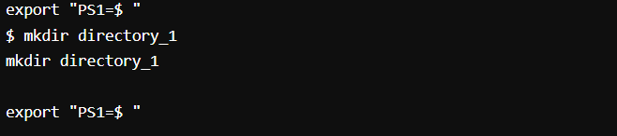

1. **ls -** Lists the contents of a directory.

Example: ls lists all files and directories in the current directory.

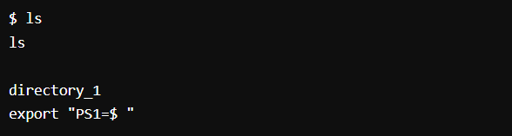Example: ls -l lists in long format with detailed information.

1. **cd -** Changes the current directory.

Example: cd Documents changes the current directory to the Documents folder.

Example: cd .. moves up to the parent directory.

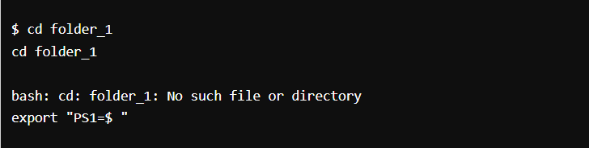

1. 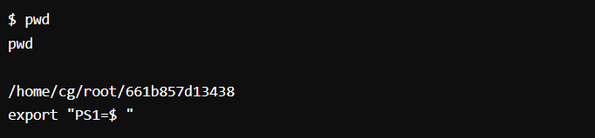**pwd** - Prints the current working directory.
2. **Touch** - is used primarily to change the file timestamps—specifically, the access and modification times of a file or directory.

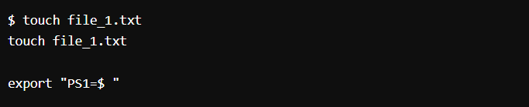

1. 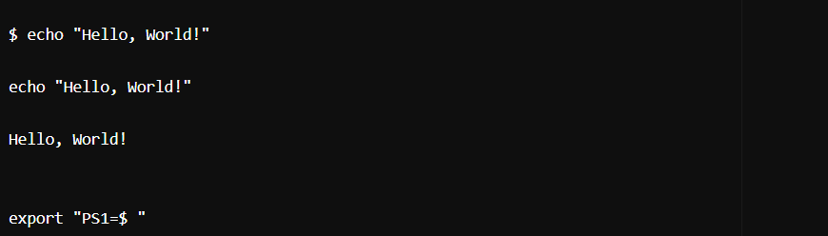**Echo** - is a fundamental utility used to display lines of text or string values to the standard output, which is typically the terminal screen.
2. **cat** - Concatenates and displays files.

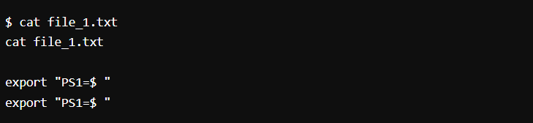Example: cat file.txt displays the contents of file.txt.

1. **rm** - Removes files or directories.

Example: rm file.txt deletes the file.txt.

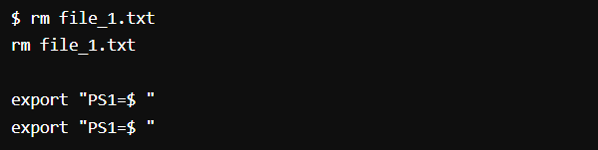

1. **cp** - Copies files or directories.

Example: cp source.txt destination.txt copies source.txt to destination.txt.

1. **grep** - Searches for patterns in text.

Example: grep "hello" file.txt searches for the word "hello" in file.txt.